K-2 Fun Fitness Weekly Challenge

Your Goal: To perform each of the 5 strength exercises each day!
Challenge you family members to do this with you! These exercises use your own body weight to make you stronger. Work hard and have fun!

1. Toe touches – Stand tall with both hands over your head. Bend forwards to touch your toes and then stand back up.
2. Squats – From a standing position sit back like you are going to sit in a chair. Stand back up.
3. Push-ups – You can do these from your knees or against a wall.
4. Heel raises – Stand tall then lift up onto your tiptoes and hold, then lower.
5. Forward facing bridge – Hold this position while you say the whole alphabet.

15 toe touches
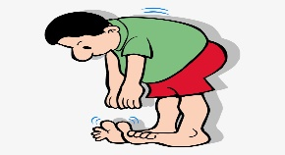

15 squats

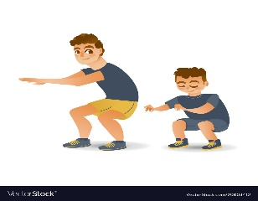
10 push-ups
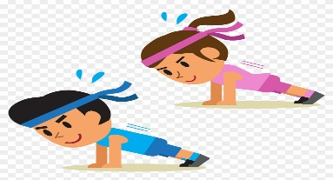
15 heel raises

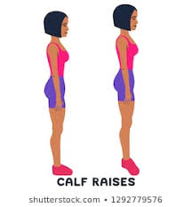
Forward facing bridge

