FITNESS GAME BOARDS and SCAVENGER HUNT
Can be used by viewing, redrawn or printing, if you have that option.

Fitness Game Board #1
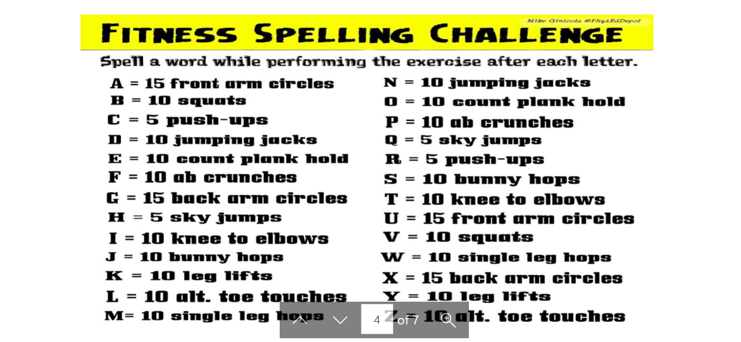

Fitness Game Board #2

