3-5 Fun Fitness Weekly Challenge

Your Goal: To complete each of the 4 strength exercises and skipping or jumping jack challenge each day!

Challenge family members to do this with you! These exercises use your own bodyweight to make you stronger. Place a check mark in the calendar each day you do the exercise. You can choose between skipping or jumping jacks for your cardio challenge. See how many times you can do the exercise in 1 minute and put the number in the space on the calendar. Try to improve each day. Work hard and have fun!

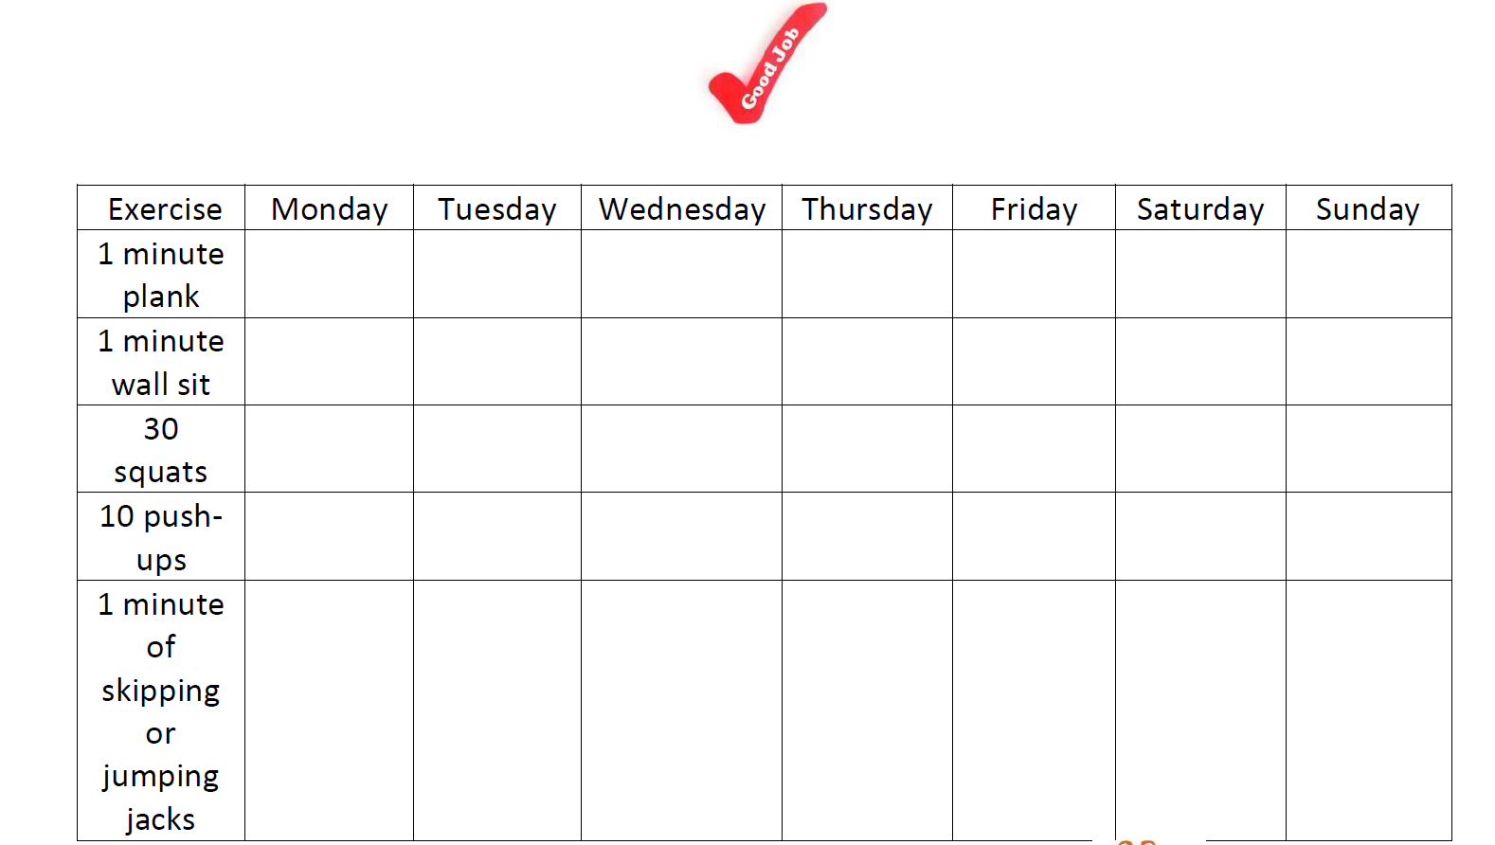
Have Fun and remember to get outside and play for at least 30 minutes a day!

